Write a class named RetailItem that holds data about an item in a retail store. The class should store the following data in attributes: item description, units in inventory, and price.

Once you have written the class, write a program that creates three RetailItem objects and stores the following data in them:

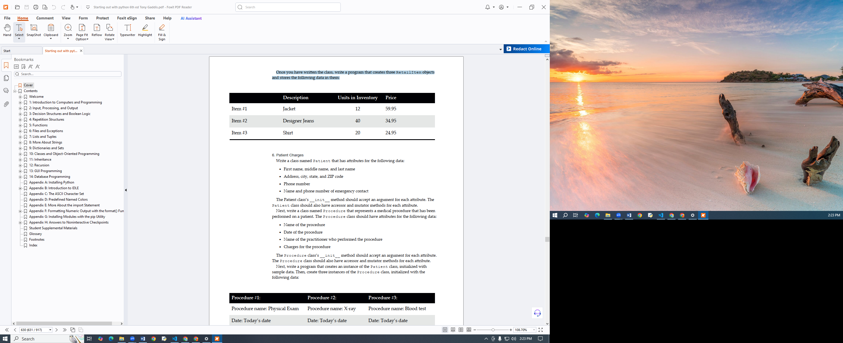

Create a CashRegister class that can be used with the RetailItem class. The CashRegister class should be able to internally keep a list of RetailItem objects. The class should have the following methods:

A method named purchase_item that accepts a RetailItem object as an argument. Each time the purchase_item method is called, the RetailItem object that is passed as an argument should be added to the list.

A method named get_total that returns the total price of all the RetailItem objects stored in the CashRegister object’s internal list.

A method named show_items that displays data about the RetailItem objects stored in the CashRegister object’s internal list.

A method named clear that should clear the CashRegister object’s internal list

Demonstrate the CashRegister class in a program that allows the user to select several items for purchase. When the user is ready to check out, the program should display a list of all the items he or she has selected for purchase, as well as the total price.